**Title: Stargate: Explore The Galaxy Through Factoring**

**Objective:** As a member of Stargate Command, your mission is to explore the galaxy, activate ancient Stargates, and solve the mysteries of the cosmos. Use your mastery of factoring to overcome challenges, defeat alien threats, and uncover the secrets of the universe.

Goal: Master factoring by using GCF (greatest common factor), grouping, and trinomials.

Here are some ways to incorporate GCF, grouping, and trinomial factoring into Stargate game:

**1.Stargate Activation:**

* **GCF:** Require players to factor out the GCF of a Stargate activation code to unlock the gate.
* **Grouping:** Use grouping to factor complex Stargate activation codes, requiring players to identify common factors within the code.
* **Trinomials:** Present trinomial equations as part of the activation sequence, forcing players to factor them to unlock the gate.

**2. Alien Artifacts:**

* **GCF:** Alien artifacts might require players to factor out the GCF of an inscription or code to activate or understand the artifact.
* **Grouping:** Present artifacts with complex inscriptions or codes that require grouping to decipher.
* **Trinomials:** Use trinomial equations to represent the energy signature of an artifact, forcing players to factor them to interact with it.

**3. Combat Challenges:**

* **Enemy Shields:** Enemies could have shields protected by factoring equations. Players must factor the equation to break the shield.
* **Weapon Upgrades:** Factoring trinomials could unlock new weapon upgrades or abilities.
* **Boss Battles:** The final phase of a boss battle might require players to solve a complex factoring problem to defeat the enemy.

Background: Possible potential backgrounds for the game

* Ancient Egyptian
* Alien planet

1. **Alien Civilization:** The game could take place on an alien planet inhabited by a technologically advanced civilization. Players could interact with aliens, learn their language, and solve their problems using factoring.
2. **Dangerous Environment:** The planet could be a hostile environment with dangerous creatures, extreme weather, or natural disasters. Players would need to use their factoring skills to navigate the terrain and survive.
3. **Ancient Ruins:** The planet could be home to ancient ruins filled with puzzles and challenges. Players would need to solve factoring problems to unlock the secrets of these ruins.
4. **Alien Technology:** The planet could be filled with advanced alien technology that requires factoring to operate or understand.

Here are some iconic Stargate artifacts that could incorporate into the game:

**Ancient Egyptian Artifacts**

* **The Eye of Ra:** A powerful artifact that can control the minds of others.



* **The Staff of Ra:** A staff that can manipulate energy and create force fields.
* **The Book of the Dead:** A sacred text that contains ancient knowledge and secrets.

**Goa'uld Artifacts**

* **The Zat'nik'tel:** A Goa'uld energy weapon that can be used to stun or kill opponents.

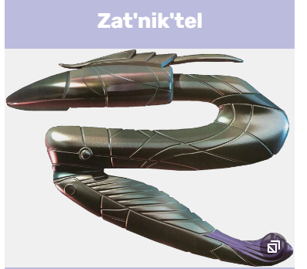

* **The Goa'uld Ring:** A device that allows the wearer to travel through the Stargate.
* **The Tok'ra Staff:** A staff used by the Tok'ra, a rebel faction of Goa'uld.

**Ori Artifacts**

* **The Ori Staff:** A powerful weapon used by the Ori, a fanatical religious sect.
* **The Ori Device:** A device that can control the minds of others and instill religious beliefs.

**Other Artifacts**

* **The Ancient City:** A hidden city built by the Ancients, a powerful race that once inhabited the galaxy.
* **The Atlantis Crystal:** A powerful crystal that can control the city of Atlantis.
* **The Destiny:** A spaceship built by the Ancients that can travel through the Milky Way galaxy.